**SGX Developer’s Guide**

**Environment Setup**

September, 2016

1. **Prerequisites**
   1. Download Java(1.7) at <http://www.oracle.com/technetwork/java/archive-139210.html>
   2. Download a compatible version of STS at <https://spring.io/tools/sts/all>
   3. Download Apache Tomcat8 <https://tomcat.apache.org/download-80.cgi>
   4. Microsoft SQL Server 2014
   5. Elastic Search 1.0.2 <https://www.elastic.co/downloads/past-releases/elasticsearch-1-0-2>
   6. SVN access.
2. **Setup steps**
   1. Open STS and create a new workspace for the project.
   2. Using your SVN credentials browse to <https://wealthmsi.svn.beanstalkapp.com/sgx> 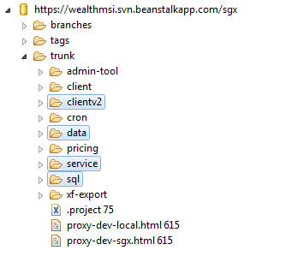
   3. Checkout the **clientv2**, **data**, **service** and **sql** projects, use **checkout as a project in the workspace** option for all of them 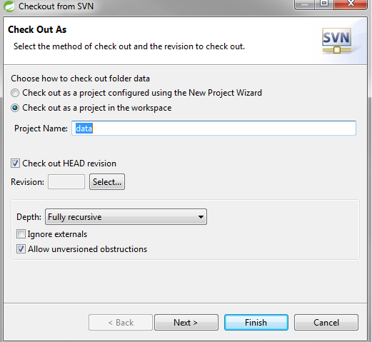
   4. In the project explorer right-click on the **service** project, go to configure and choose **convert to Maven Project**, apply the same step to the **data** project 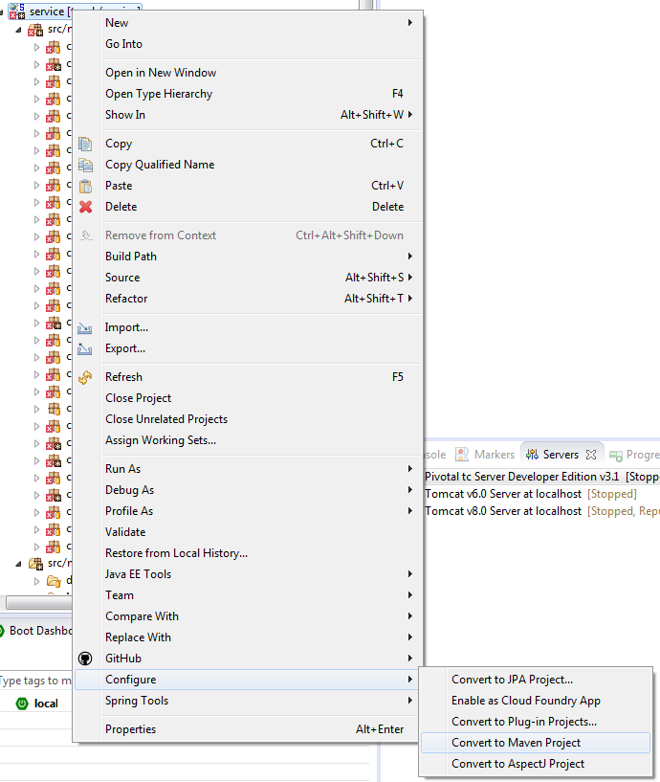
   5. Go to the **Servers** tab and choose add new server ->Apache -> Tomcat v8.0 Server and point to the Tomcat 6 installation directory.
   6. In project explorer, expand servers and go to **Tomcat v8.0 Server at localhost-config** and replace server.xml with the attached one  and add the attached keystore file in the C:/ directory , this will make Tomcat support https on 443 port and port 80 for http(make sure no other processes are using port 80).
   7. Add the service project to the list of applications on Tomcat and press finish 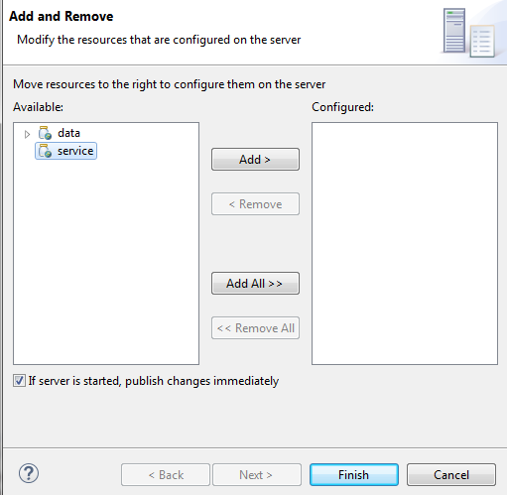
   8. Double click on the Tomcat instance in the Server explorer and go to modules tab
      1. Click on add External Web Module.
      2. Browse the clientv2 physical path on he computer
      3. Make sure the path is set ‘/’ (with the single quotes). 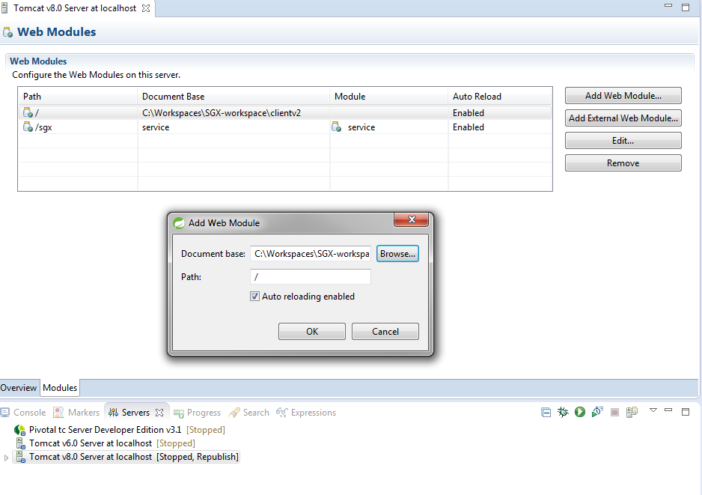
   9. On the source project, expand go to **/service/src/main/resources/META-INF/properties** and copy dev.application.properties contents to application.properties.
3. **Database Setup**
   1. If the dev instance is being used, make sure that the right configuration is present for the database details (found in one of the application.properties files), if a local instance being used, proceed with the following steps.
   2. Make sure that SGX database schema is existing on the local SQL Server instance
   3. Go to the **sql** project in STS and run the scripts in the numbering order they are named with (the un-numbered ones are drop statements for starting over). 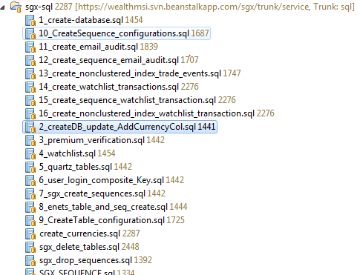
4. **Running the Application**
   1. Run the Elastic search instance from the installation directory **bin\elasticsearch.bat**
   2. Start the Tomcat8 Server in STS
   3. Run the Main.java in **data** project found in **com.wmsi.sgx.Main** and usually takes around 40 minutes to finish.
   4. Browse and make sure it is successful to <http://localhost/iframe.html>